Date:-

To Whom It May Concern

Subject:- Declaration of Authorised Person

We (Company Name) would like to authorize (Name and designation of authorized person) to sign all the documents on behalf of our company for Telemarketer/ Enterprise related activities.

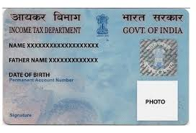
Contact Person Name -
Contact Number -
Email Id-
ID Proof Number -
ID Proof Type - PAN
Copy of ID Proof - PAN

Authorized Signatory

(Seal & Sign)

